What is Family for You?
1. Discuss the following questions with your classmates.

- What are nuclear and extended families?
- What is a family to you? What is so special about family?
- Who is the most special person in your family? Describe him or her!

How Do Male and Female Roles Differ in Your Family?
(adapted from Schulten K. and Altavena L. 2012. Retrieved from
http://learning.blogs.nytimes.com/2012/02/09/how-do-male-and-female-roles-differ-in-your-family/?_r=0)

2. Read several opinions from high school students in the US about the roles in their families.

Weinu:
In the modern-day family, the unwritten rule for gender roles is that the mother takes care of the children, feeds them, nurses them, and teach them, and the father works and acts as the bread-winner of the family. This paternalistic system that is predominant and prevalent in most of the world’s cultures is derived from our basal hunter-gatherer society: the men leave the home often and hunt for food while the females are sedentary and forage for food. Surprisingly, female foragers bring over 90% of the food in the clan/family and thus they were the ones most responsible for feeding children. As a result, these primitive roles have trickled down to our much more advanced society and still the mother are perceived as being responsible for taking care of the children. In my family, both my father and my mother have equal responsibility in educating and caring for us. On weekdays, my mother cooks most of the food but on weekends, my father cooks nearly all of the food. My father is in charge of our education and he teaches us English, Chinese, science and math. However, my mother is an educator by profession and she also plays a strong part in teaching us Chinese. Finances are managed by my father, but purchasing groceries is managed by my mother. Maintaining the house is managed by my father, but planting flowers and taking care of the garden is managed by my mother. So, I can clearly say that the past stereotypical gender roles demarcating the responsibilities of man and women have effectively been dissolved, as they no longer hold any relevancy in a society where both spouses have an equal opportunity at management.

Gwen:
In my family, my mom’s always been the designated parent. She does almost all the cooking, housework, etc. She used to be a stay home mom when I was first born, but now she works part time and still takes care of my sister and I. My dad on the other hand does the yard works and helps with our homework. My mom is usually around the house more and does everything she can for us. My dad works full time and always gets home very late, so we don’t spend as much time with him unless he’s off from work or gets off early.

David:
In my house, I’d say that my parents do equal amounts of “parenting”. My mom and dad usually both try to help me with homework when they can, and they both attend my school events. My mom cooks on the weekdays when my dad comes home from work late, and my dad cooks on weekends. Even when I was small, I remember that my mom and dad both spent around the same amount of time helping me and taking care of me. Our family doesn’t really have distinct gender roles other than the fact that my mom does the laundry. Other than that, everything else is pretty much equal. I don’t think the Census Bureau’s designation is fair. No one gender should be limited to a certain task in the household, such as taking care of kids, doing housework, etc. Whether the mom or the dad cares for the child, it should be considered the same thing, because ultimately it’s the parent caring for the child. If I have children when I’m older, I feel like the housework would naturally divide itself between me and my wife. Whenever we have time, we would both do housework, that way no one person has to do the same thing over and over again. Designating a certain gender to do a job isn’t the fair thing to do; both genders in the family should do equal amounts of work to keep it running.

Christian:
In my opinion, my mother is the designated parent in my family. My dad leaves to go to work before I leave for school and comes home every day around 6 in the evening, so most of the “caring” I receive from my parents is from my mom. My mom runs a daycare at home so she is literally at home almost all of her day. Sure, my dad sometimes cooks dinner for us or hangs out with me, but it’s usually just me and my mom at home. Also, when my dad comes home, he usually just goes on his computer or does some chore that he has to do around the house, so most of the emotional support and caring comes from my mom. Don’t get me wrong, I know for a fact that my dad loves me to death, but sometimes I feel slightly disconnected from him because we don’t really communicate with each other.

RJ:
I live with my mom and grandparents. My parents are not divorced, but my father lives in a different country due to business. He visits us about every 3 months. This is how we’ve been living with the exception of my sister staying away at college. My mom has to do a lot of work. She works from 8-4:30 everyday. When she comes home she has to take care of my grandparents, make food, and buy groceries. Before she goes to work, she has to wake up at 6 to prepare food for everyone. While my mom is gone to work, my grandmother cleans the house and makes even more food. When I come home from school, my mom does not ask much from me. She just wants me to make sure my room is tidy and that I keep my clothes nicely. Other than that, she wants me to keep school as a first priority. Even though my father generates more of our household income, my mom still plays the role of a father and a mother in his absence. She has to go to work and do almost every single house chore possible. However, when my dad is here to visit he does everything he can to help out. He doesn’t just sit around and order my mom to do stuff, rather he actually cooks, cleans, and does the chores for her to compensate for his absence. Collectively, my mom does the most parenting around the house along with majority of the housework, but genders don’t seem to determine roles in our house since we all have a part to play that’s crucial for the house to function.

3. With a friend, discuss the following questions:
- Who are the main members of your family?
- Who would you say does most of the “parenting” in your house (even if that person is neither a mother nor a father, but a grandparent, sibling or someone else)?
- Who does most of the housework?
- To what extent do the roles in your house seem to fall along traditional gender lines?
- Why?

Note:
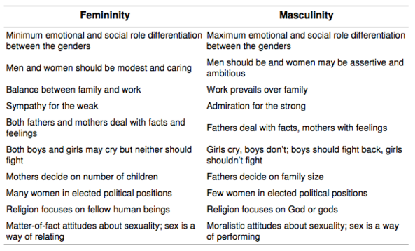
(retrieved from http://www.wikiwand.com/en/Hofstede's_cultural_dimensions_theory)

